# Literature Review

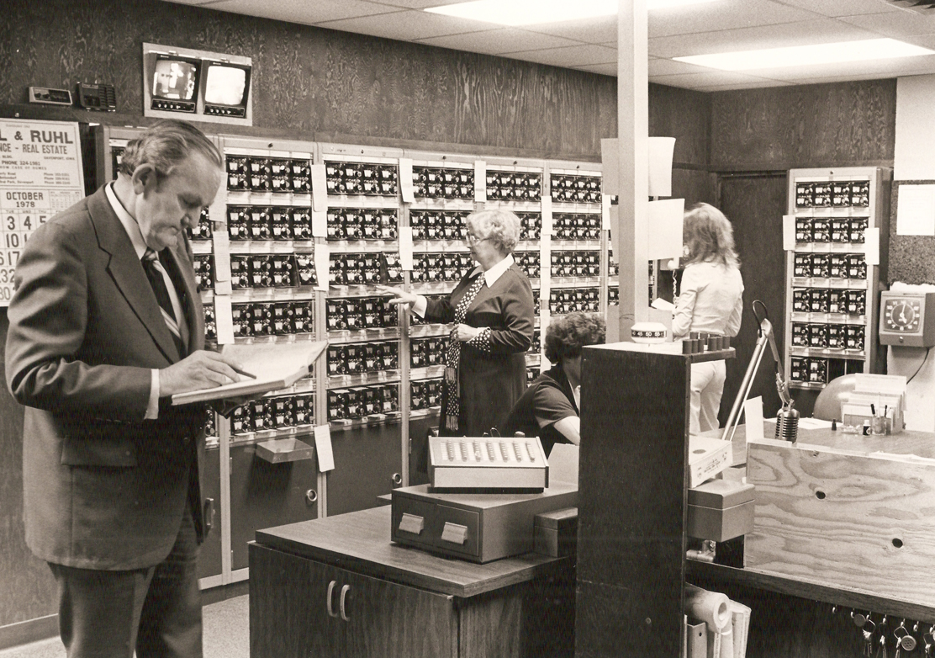

In ,recent years, home security has shifted from simple control panels and deadbolt keys to cool, desirable technology gadgets that integrate items into a wide range of homeowners. While Jetson's era has just arrived, technologies in today's smart home, such as aspects of home security camera viewing, may be enough to blow the minds of our ancestors. There are so many new things being invented when it comes to providing security. Not only cameras, but also things like these Verify biometric smart safes, but there are many other things that have also changed and improved from the past.

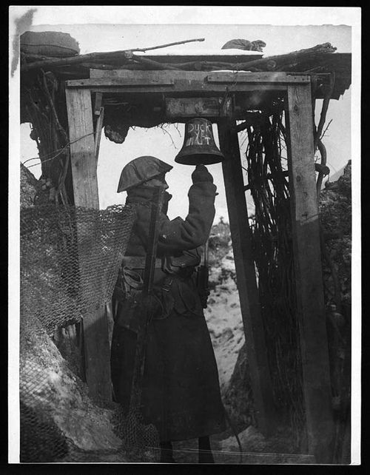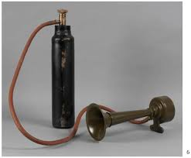

The first home security systems

When World War I ended, an increase in crime followed. As a result, Americans became sensitive to security needs and were eager to find ways to protect themselves and their property. Additionally, many insurance companies began offering premium discounts to alarm subscribers. These events produced a consumer demand for alarm systems.

During this time, homeowners may have subscribed to a service called door shakers— a group of night watchmen who would shake subscribers’ doors each night to ensure they were locked. More advanced users may have installed an alarm system that used electromagnetic contacts fastened to doors and windows, which were connected to a battery and bell. These systems were monitored by a central station that sent a guard to the residence when the alarm was triggered.

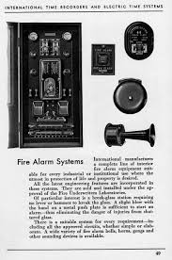

As security system technology evolved, so did fire alarm technology. In 1962, a team of Canadian researchers published a study of the life-saving effects of heat and smoke. The team examined the 342 fire deaths in Ontario from 1956-1960 and concluded that if households had access to heaters or smokers, mortality would be reduced by 8 percent and 41 percent, respectively.

Modern smokers' alarms often use a combination of sensors - photoelectric and ionization - to detect smokers and smokers and are linked to alerting firefighters to another part of the home.

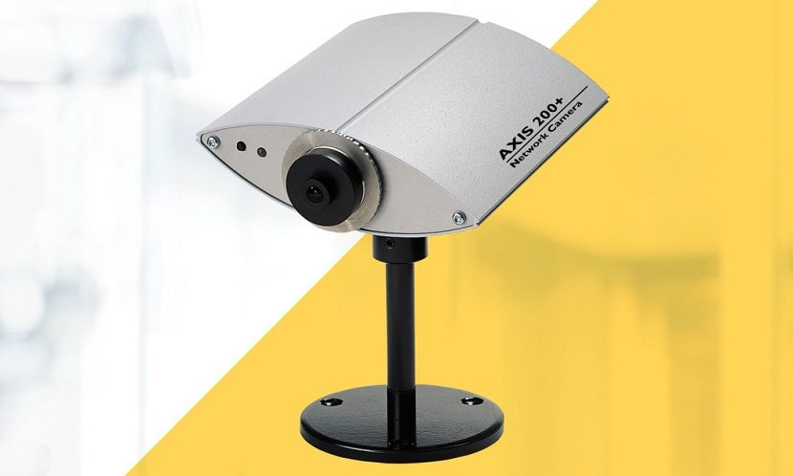

The introduction of IP cameras attached to the network has been a major technological change in the CCTV industry. Axis introduced the first IP cameras in 1996. These new cameras use an Ethernet network to connect to a coax cable. Video signals are now sent as digital signals instead of analog signals. The new way of communicating has become a difficult concept for older analog security vendors.

# Literature Review

The proposed design created by the group derives the same concept as in the above examples and is created in a way which is useful and practical in a real world application. The automatic alarm security system uses a microcontroller by Arduino. Arduino Uno a microcontroller board is equipped with sets of digital pins as well as analog pin which makes it possible to interface with or expansion with different circuits and board. The microcontroller controls four devices which are 4*4 keypad used to input authentication form the user. Then an (Infrared) IR sensor is used to detect if there are users there to use the keypad or its being remotely operated in this case the authentication will not happen if the keypad is operated remotely. Then the servo motor is used to rotate or open the door. A servomotor is a rotatory actuator that provides precision on the control of its linear position, velocity and acceleration. The last device is a buzzer which sets off loud buzzing sound which sets off it the password is wrong and the keypad is been accessed remotely.

# Methodology, Tools, Technology, Techniques

The project was designed for the propose of solving problem of security. The problem was space was then identified. In the country we all lived in the security measures are outdated and still use the traditional lock and keys. We identified the problem space. Then moved on to solve the problem by producing a security system which is modern and doesn’t require any learning time basically it means it’s easy to operate. The goal of the project was to produce simple and powerful security system which provides modern Infosys on alarm.

The hardware required for the project are:

Arduino esp32

Arduino Uno

Servo motor

Buzzer

Keypad

IR Sensor

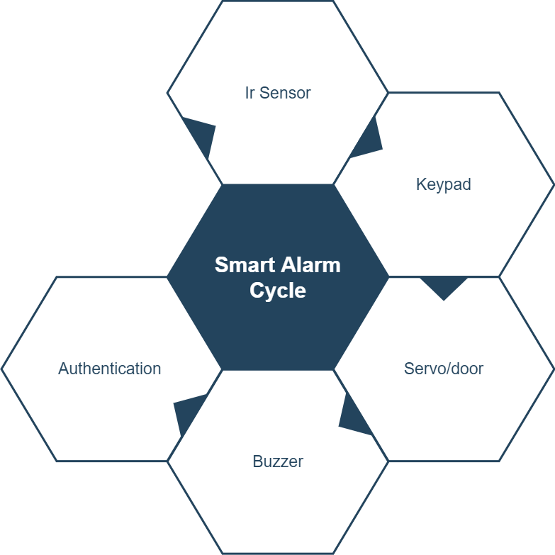

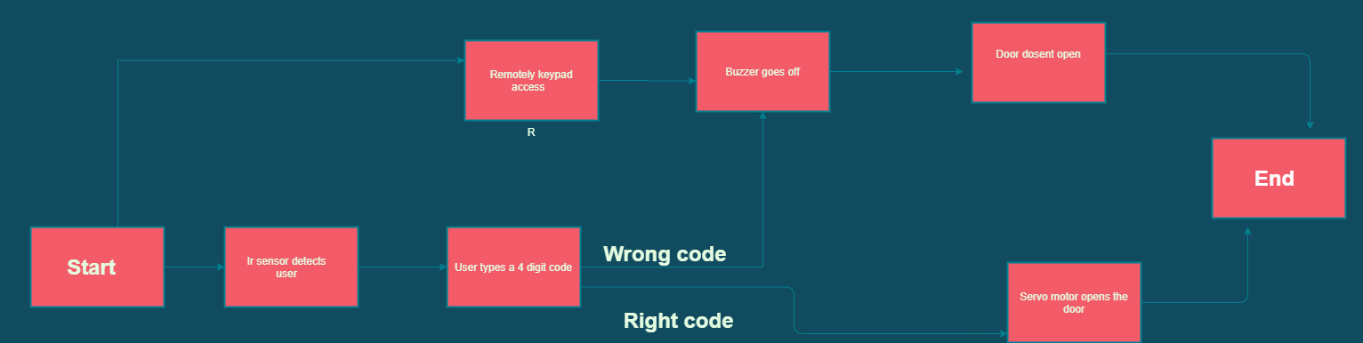

Our project is a smart alarm which is an authentication system using a keypad where the right code allows access whereas the wrong code produces an alarm like sound. The authentication system is protected from remote hackers by a sensor which doesn’t allow authentication unless a person is detected. The process starts when a user is detected by a sensor then user proceeds to inputs a 4 digit code at the keypad if the authentication is correct the servo motor opens the door .If the code is wrong the authentication doesn’t happen while the door stays locked instead a buzzer goes off. The buzzer will still go off if the keypad is accessed remotely. To authenticate and open the door IR sensor should detect a user typing code if the IR sensor doesn’t detect anyone even if the code is right the buzzer will go off. The programing of the whole project has been done in Arduino IDE.

# Update Project Plan

The project plan was preplanned and derived for the team to know the progress of the project. The project plan was updated whenever there were changes made in during the project. There are three stages of a project life cycle which are stage plan, next stage and exception plan. The project manager is responsible for creating he project plan and if helped by other team members.

The project plan we derived at first sight needed to be changed to updated project plan. The updated project plan will have some minor areas to update in the project. The new plan will have the use of PIR Sensor instead of the IR sensor. The meetings regarding the project will now be conducted in zoom for better coverage.

The hardware must be update for better operation abilities as all the hardware used were for prototypes there were easy were and tear and it had to be change rapidly. The way the data stored will also be changed in the update project plan.

# Risk analysis and Risk log

The project has never had the time and unlimited development funding. Such time and financial constraints place limits on the amount of performance and/or quality that should be achieved within a project. Testing this translates into decision-making about what to test, how to test, and how much to test. After the risk are identified they are now presented to recognize its subjective and quantitative danger on the project. The identified problems are solved to move the project more smoothly and achieve project goal faster.

|  |  |  |  |  |  |  |
| --- | --- | --- | --- | --- | --- | --- |
| NR. | Risk description | Source | Probability | Impact | Risk mitigating actions | Risk owner |
| 1. | Hardware becomes inaccessible to the whole group | Further lockdown extension | Medium | High | Work in college by suited members | - |
| 2. | Coding is difficult | First time coding in IOT hardware | Medium | High | Taking more coding lessons | Whole team |
| 3. | Scheduling becomes difficult | Other assignment’s pressure | Medium | Medium | Completing other assignments early | Team leader |
| 4. | Difficulty in using hardware | First time doing this kind of project | Medium | High | Using hardware with safe precautions | Whole team |
| 5. | Work load becomes imbalance | Team members slacking off | Low | Medium | Working on proper schedule | Whole team |
| 6. | Hardware suppliers become unavailable | Less products due to lockdown | Low | High | Exploring new suppliers. | Team leader |
| 7. | Hardware failure | Sensors won’t work. | Medium | High | Consider backup sensors | Team leader |

# Recommended and Future work /Application in other sectors.

Smart alarm has major factor in solving security problem by making it practical and easy. Smart alarm plays a major factor in changing the infrastructure of security from traditional lock and key system. This can make managing advance security easier. In countries like Nepal there are major market for security system. There are still many international companies selling this product in Nepal. Due to being from international brands the product tends to be costly to its domestic audience. The application of our project can be used in different sectors as well as combination with other security options. In the future there would be improvement in the project face recognition and Automatic danger detection from machine learning. Which can make the AI predict danger before it happens? As the world grows smarter and technological advance security system also needs to change. The automation of security can help people feel more secure of their homes. There are many applications for this project as the traditional system are fading. Security is something people would not compromise so if a smart advance security system which can be integrated with your smart devices distributed to market it would be a good seller.

# Conclusion

Protection against theft is a critical issues and our technologies can make it is easier and simpler. Newer smarter way to protect the things you love. This project will be cost effective as it will only require installation fee. The operating cost would be minimum. The project will have durability rather than traditional locks which can rust over time. Destroying or broken looks can be common constant changes may be a Hassel. The smart alarm can save time cost and be durable at the same time. The world is changing at a faster pace our smart alarm will fill the gaps between technology and security.

# References

**There are no sources in the current document.**